Connor Bailey

CS-360: Mobile Architecture & Programming

Professor Benavente

03 August 2025

Module Four Assignment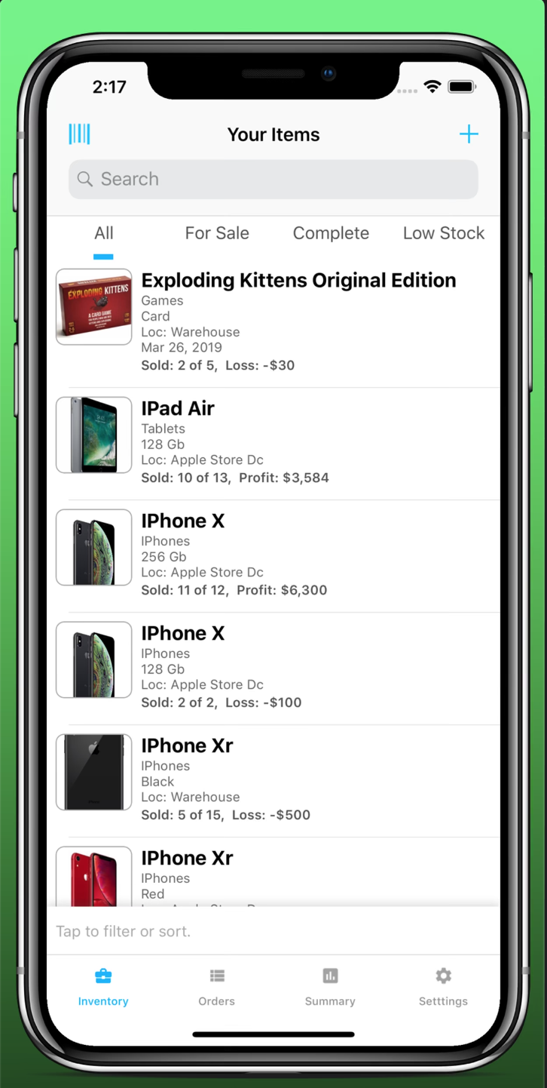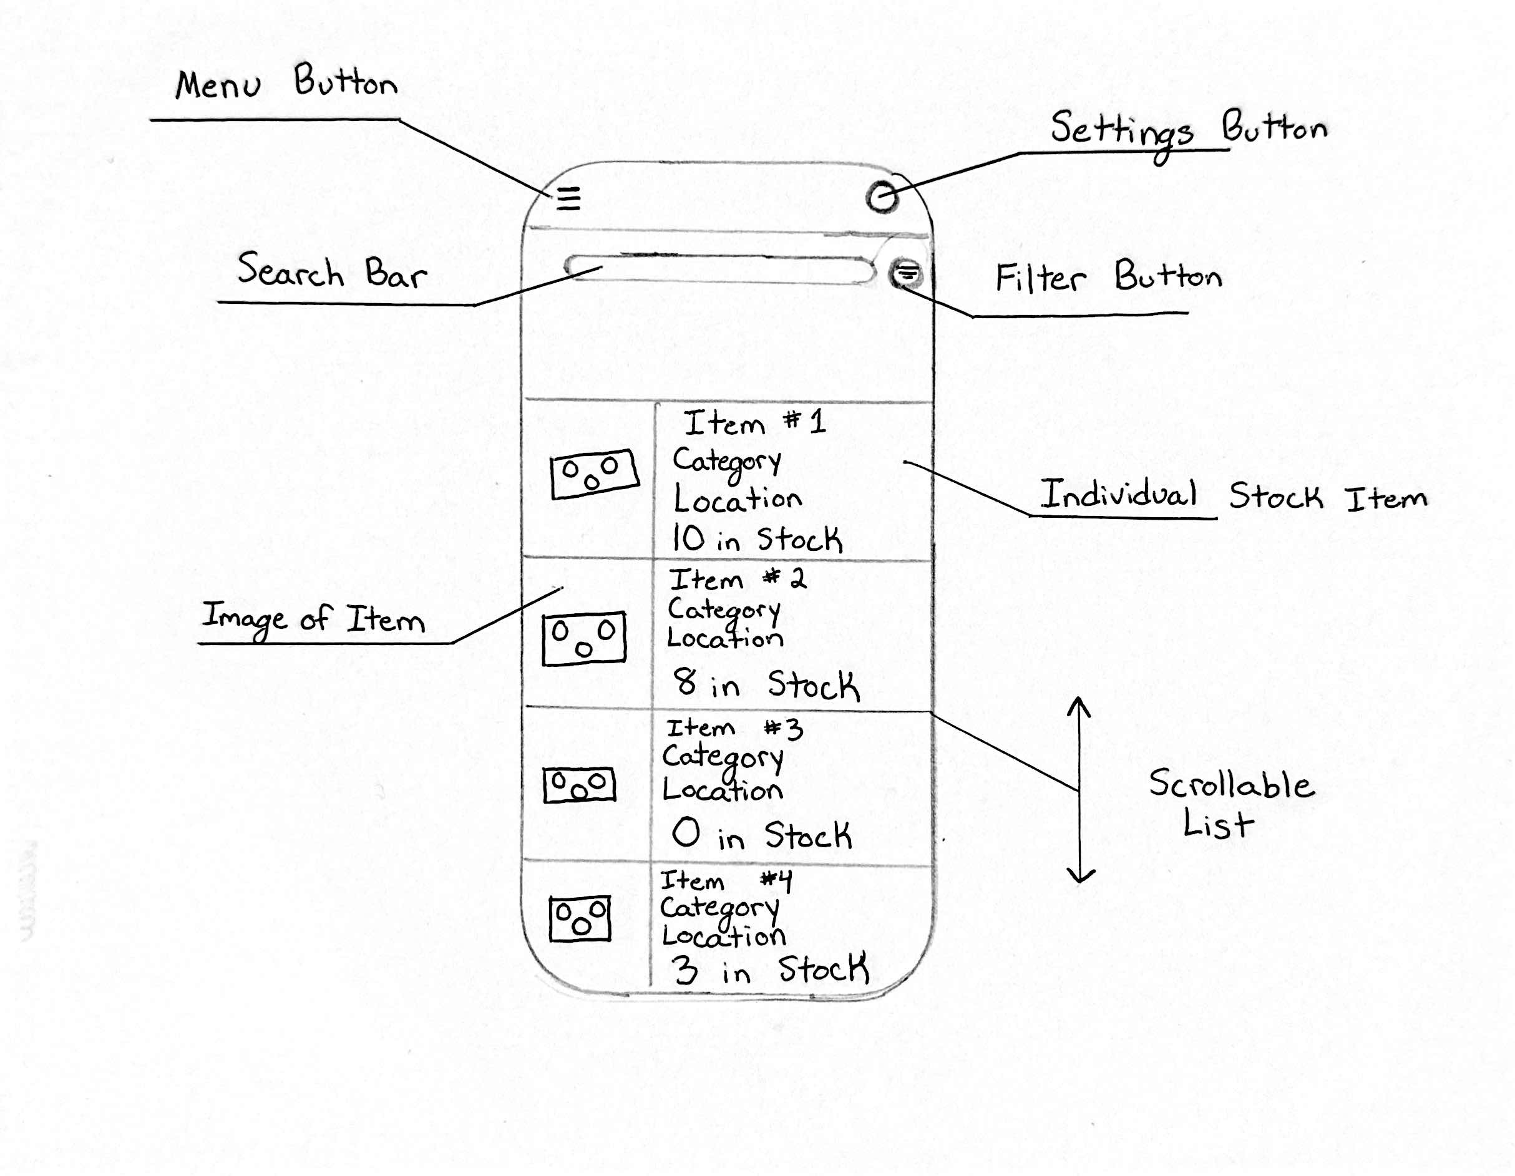

# Design Decisions Explanation

For this assignment, I chose to to recreate the app Inventory Now. This is an inventory management app for warehouse employees that I used for the Project One Milestone. I chose this because designing the main interface screen will aid in my final design for my Inventory App for Project Two. I adapted the iOS version of this app to the Android Interface Guidelines. The first thing I adapted was moving the TabView on the bottom of the interface into a menu option. When this menu button is pressed, a menu will slide out from the left side of the screen and present the same options for "Inventory", "Orders", "Summary", and "Settings". Users will be able to navigate between these screens through this menu. The search bar has been designed to be a floating search bar that will sit above the list content, and can be used by users to search for any item in the list of warehouse items visible in the "Inventory" screen. This search bar will remain on both the inventory screen and the orders screen but will be hidden in the summary and settings screen. A button will be added next to the search bar that allows the user to filter the items visible in the list. I feel like this condenses the existing design used by Inventory Now and reduces the cognitive load for the user, as there will be less options visible directly on the screen. The main content on the Inventory screen detail is the list of inventory items in the warehouse. In the original design, this is a vertical list that can be scrolled through. Tapping any of these items will bring you to an Inventory Details screen, where quantities can be adjusted, barcodes can be scanned, and other information (e.g. Timestamps) can be viewed.